How to create a LUN in EMC storage box for VB01

http:// 10.42.20.25

credentials

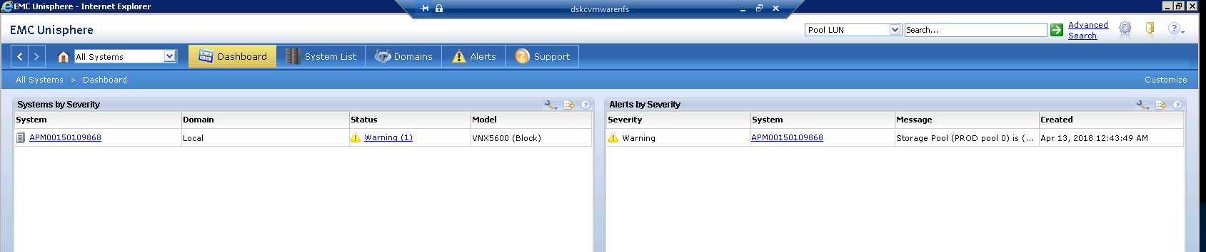

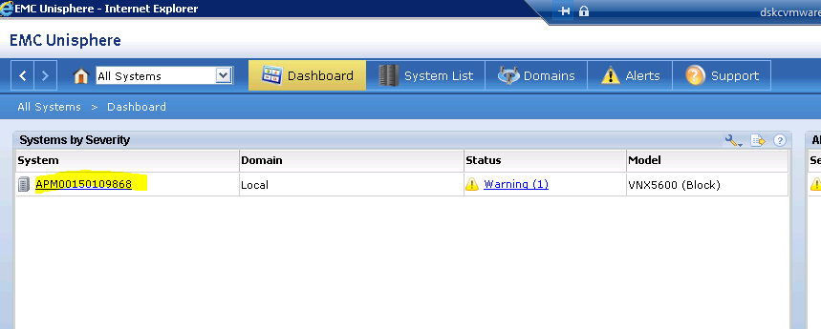

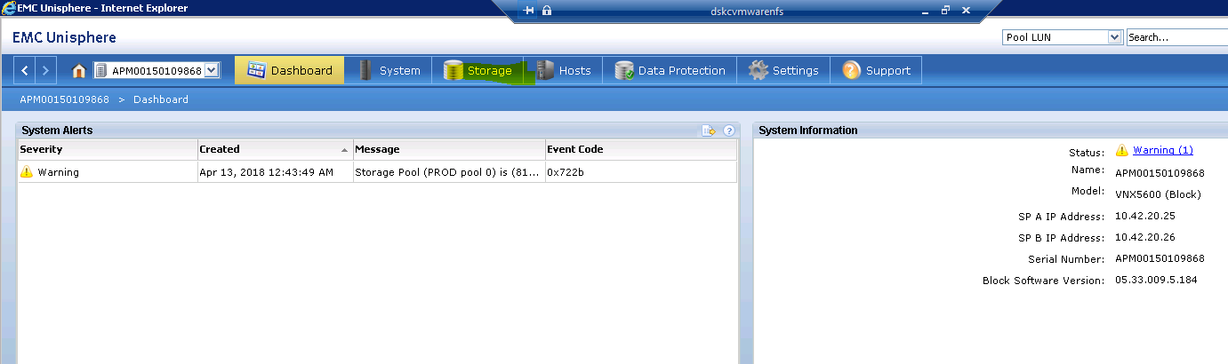

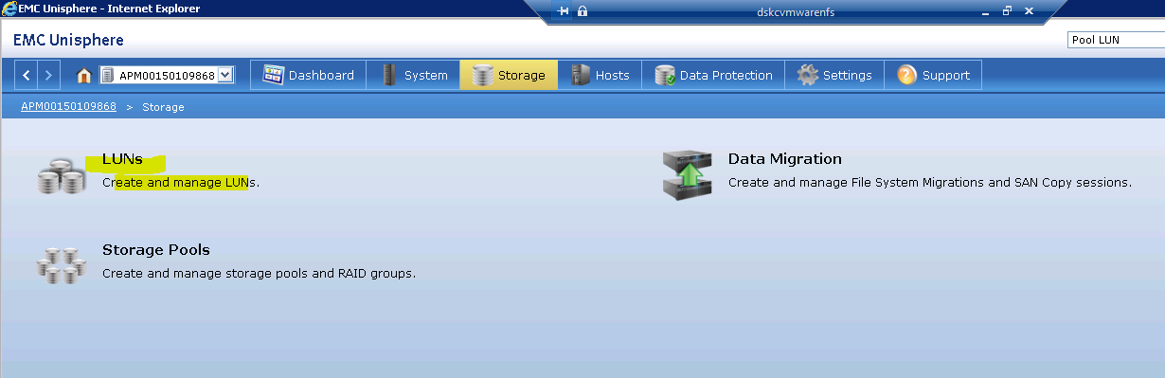

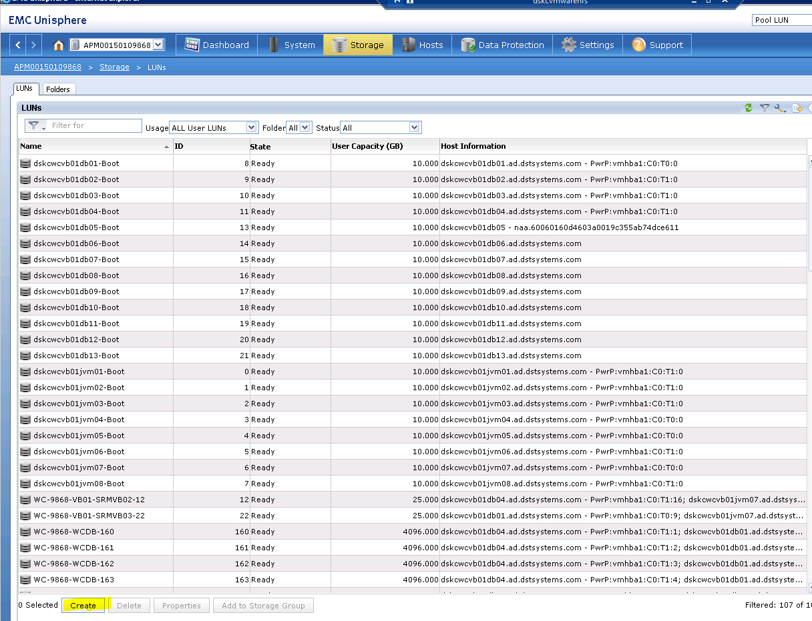

Specify the space 4096 GB(4TB)

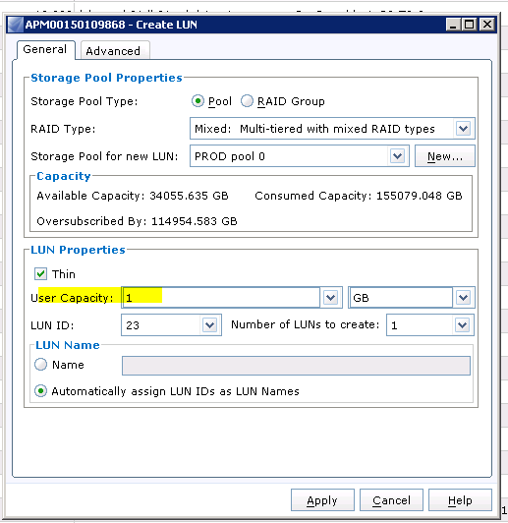

Right click created LUN and select Proprieties

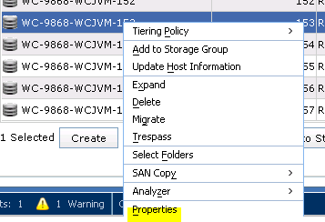

Rename Name as per your environment

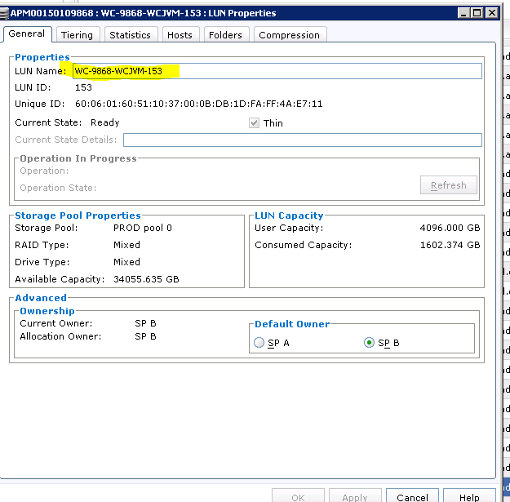

Than again right click created LUN and select assign host groups 🡪select ESXi s to map to ESXi Luns.